WEB APPLICATION PENETRATION TESTING

Access Control Assessment Report
User ID Controlled by Request Parameter, with Unpredictable User IDs
Platform: PortSwigger Web Security Academy | Tool: Browser

1. Executive Summary
This assessment tested the PortSwigger lab “User ID controlled by request parameter, with unpredictable user IDs”. The application used a user identifier in a request to retrieve account information. Although the identifier was not a simple or sequential value, it could be obtained from another location in the application and then used to request another user's account page. The test successfully accessed Carlos's account information and the lab confirmed completion.

2. Objective and Scope
Objective: determine whether an authenticated user can access another user's account data by changing a user identifier in an application request.
Scope: the intentionally vulnerable PortSwigger Web Security Academy lab environment. The findings and impact described here are limited to the supplied lab evidence.

3. Methodology
- Logged in to the lab using the provided test account.
- Inspected application URLs and identified a user identifier used in a request.
- Observed that the identifier was an unpredictable UUID-style value rather than a sequential user number.
- Obtained the target user's identifier from another application location.
- Used the target identifier in the account request and accessed Carlos's account information.
- Confirmed that the lab displayed its success message.

4. Finding
The application relied on the user ID supplied in the request but did not adequately check whether the authenticated user was authorised to access the corresponding account. The identifier's unpredictability made guessing harder, but did not prevent access once the identifier was discovered.
This is an IDOR / broken access control issue that enables horizontal privilege escalation: one user can access another user's data at the same privilege level.

5. Evidence
The screenshots below show the identifier discovery, access to Carlos's account, and lab completion. Carlos's API key has been redacted from the report copies.
Figure 1 — User identifier in application URL
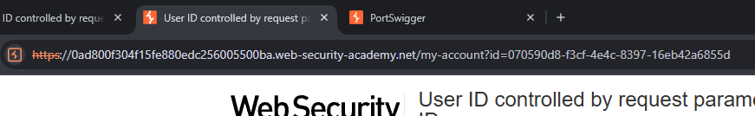
A user identifier appears as a parameter in the application URL.
Figure 2 — Request using the target user's identifier
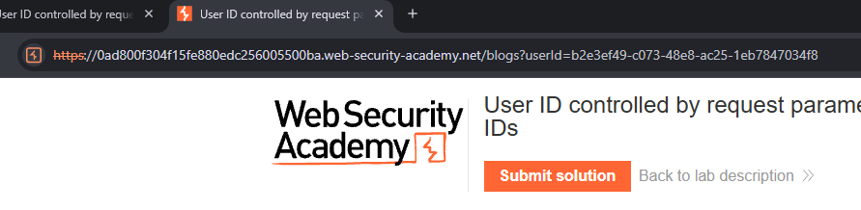
The account request uses the target user's identifier rather than the logged-in user's identifier.
Figure 3 — Access to Carlos's account information
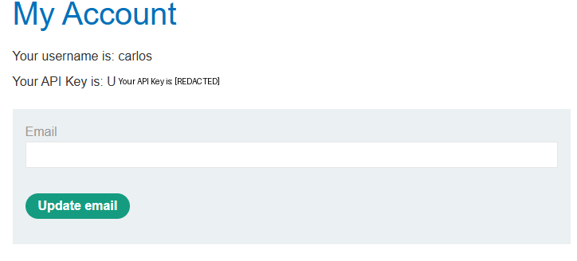
The account page displays Carlos's account information, demonstrating unauthorised access.
Figure 4 — Lab completion
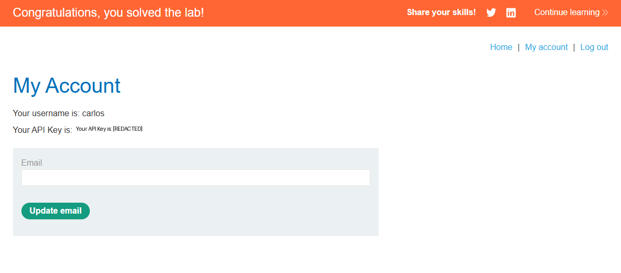
The PortSwigger success banner confirms that the lab objective was achieved.

6. Impact
An authenticated user may be able to retrieve another user's account information, including sensitive values such as an API key. If the exposed key grants access to additional services or data, the impact could extend beyond the account page. The screenshots establish disclosure of Carlos's API key in the lab, but do not demonstrate what privileges that key provides.

7. Severity
CVSS v3.1: 4.3 — Medium (indicative)
Vector: CVSS:3.1/AV:N/AC:L/PR:L/UI:N/S:U/C:L/I:N/A:N
This indicative score assumes an authenticated user is required and that the demonstrated impact is limited to disclosure of account information/API key. The score should be reassessed if the API key enables further unauthorised actions or access to additional systems. The lab completion itself does not establish those additional impacts.

8. Recommendations
- Enforce server-side authorization checks on every request that accesses user-specific data.
- Derive the authenticated user's identity from the server-side session rather than trusting a supplied user ID.
- Verify that the requesting user is permitted to access the requested account or object.
- Do not rely on unpredictable identifiers as an access-control mechanism.
- Limit the permissions and lifetime of API keys, and rotate keys if they are exposed.
- Log and monitor attempts to access other users' account resources.

9. Conclusion
The lab demonstrated that unpredictable identifiers do not prevent IDOR when the application fails to enforce authorization. Access to user-specific resources must be validated on the server for every request, regardless of how difficult an identifier may be to guess.

Reference
PortSwigger Web Security Academy — User ID controlled by request parameter, with unpredictable user IDs:
https://portswigger.net/web-security/access-control/lab-user-id-controlled-by-request-parameter-with-unpredictable-user-ids

Disclaimer
This assessment was conducted in an intentionally vulnerable PortSwigger training environment. Testing must only be performed against systems for which explicit authorisation has been obtained.

